NATIONAL IDENTITY REPERTOIRES, TERRITORY, AND GLOBALIZATION
Roy J. Eidelson*
Solomon Asch Center for Study of Ethnopolitical Conflict

University of Pennsylvania
Ian S. Lustick*
Department of Political Science and
Solomon Asch Center for Study of Ethnopolitical Conflict

University of Pennsylvania

March 2002

*Comments to the authors may be directed to royeidel@psych.upenn.edu and ilustick@sas.upenn.edu
Introduction
Events and initiatives on the continent are propelling individual states, or at least many inhabitants of these states, toward the adoption of a shared European identity. As a result, the dynamic aspects of previously secure links joining territory, political affinity, and culture are brought into view. While the thorny issues posed by globalization and its byproducts are indeed being debated and confronted around the world, efforts to “re-map” Europe into a supra-national entity with common currency and open borders are especially intriguing because they represent the clearest attempts to design, encourage, and control these transformations. The authors of this chapter welcome the opportunity to contribute to the scholarly exchange on this topic by offering a very different research perspective—an agent-based modeling approach—inspired by complexity and evolutionary theory and employing computer simulations and Lustick and Dergachev’s Agent-Based Identity Repertoire (ABIR) model.
At the heart of the ABIR model is the central constructivist notion that identities are best conceptualized as repertoires of possibilities. That is, identities emerge from multitudinous interactions among carriers of different “ways of being,” different “performance styles,” or different psychocultural stances (depending upon your disciplinary or epistemological commitments). At any level of analysis, the identity carrier (individual, group, political community, etc.) holds within it a subset of all available identities—its repertoire. Constructivist theory envisions these repertoires as offering a range of fluidity and malleability for identity carriers facing a world likely to encourage “activation” or “self-presentation” on a particular identity at one time and another identity at a different time. This activated identity substitution occurs without great difficulty when the substituting identity is part of the individual’s repertoire. Change in the composition of the repertoire itself—that is, in the set of readily available ways of being (for an individual or for a group)—is also possible, albeit only in response to relatively large outside pressures and incentives.
By setting out this now-dominant approach to identity construction and reconstruction in rather more abstract and more precise terms than is customary, we can proceed to elaborate and apply the intuitions of constructivist theory. In this chapter we seek to apply this approach to questions of what it currently means, in a national political context, to be a member of a certain national community by illuminating the fundamental relationship between location (territory) and population (the mix of “natives” and “immigrants” among the inhabitants of territorially defined states). We are specifically interested in studying these questions as they are presented under conditions of globalization which render borders among states more porous and which tend to increase proportions of immigrants within formerly more homogeneous national territories.
By applying these concepts to Europe at the dawn of the 21st century, we can move beyond objective and dichotomous designations encouraged by measuring individuals simply on the basis of habitation, citizenship, or current identity “performance.” Within our model, the full spectrum of identities available in the world includes a subset of “national” identities. Thus, in any particular national territory or country, there are a variety of different ways to be “German,” “Spanish,” or “British,” though there are, in the world as a whole, many more ways of being “non-German,” “non-Spanish,” or “non-British.” For example, an information-age young Green-oriented Berliner expresses “German-ness” in a way that is different (but equally real) from that of a Bavarian brewmeister, a neo-Nazi skinhead in Hamburg, or a Daimler-Chrysler executive in Bonn or Munich. And each of these individuals may have, in fact, the personal resources to perform his or her German-ness in one, some, or all of the other ways Germans do so. The same could be said about British identity with reference to a London Barrister, a Cockney football fan, a Pakistani shopkeeper in the Midlands, a Welsh pony-trekking guide, or a Cambridge Don. The extent to which these different identity stances are to be considered “German” or “British” may change over time, but it is important to emphasize that there are certain identity styles, or ways of being, that at any particular time or period do not fall within these categories. Thus a Venetian gondolier or a Paris taxi driver would likely not credibly be able to present himself or herself as German or British. Similarly, should a Briton or German try acting as a gondolier or a Paris taxi driver, that “identity” would be understood, in fact, as a “put-on,” as an act, and not as a “real” performance.
In short, individuals affiliated with a national state have identity repertoires that contain certain elements and exclude others. These different “native” ways of being French are “variations on the theme” of being French. There may also be identities in France that are not native French identities. In our simplified model these non-native identities, which are nevertheless held in the repertoires of many inhabitants of France along with native identities, may be thought of as “naturalized” or “immigrant” identities. These may be seen as French, but neither as “native,” (identities present only in France) nor “alien” (identities present only outside of France). At the extreme we may say that if an inhabitant of France holds no identities in his/her repertoire that are present only in France, then he/she could be considered an alien, not a naturalized French person. By extension, if no inhabitants—or only a minority of inhabitants--of France any longer hold identities in their repertoires distinctive to this territory, then we may say, indeed, that what was “France” is no longer. It is, then, differing identity repertoires, more than possession or performance of any one identity, that ultimately establishes one person as French or Spanish and another person as Dutch or German; and that makes one country France and another not France.
If identities did not arise via constructivist processes from distinctive but impermanent repertoires (e.g., if identity was instead automatically produced by some single unchanging factor), then patterns of identity politics would be much simpler. For example, if geographical location were the single determining factor, then the moment an individual emigrated from one country to another, he or she would immediately be indistinguishable from others in that country. This is clearly not the case, as the long-standing and now increasingly heated furor over issues of immigration demonstrates. At the other extreme, if identity is deemed to be purely a function of biological or early childhood upbringing, a Turk will be a Turk regardless of how long he or she works in Germany or how much he or she “tries” to be German. In sum, it is only because identities inhabit changeable repertoires that ways of being can move across a territorial or bodily border so that authentic Irishmen can adopt lifestyles or stances associated with Silicon Valley or the denizens of Parisian cafes.
Thus, constructivists are led to ask questions such as: “How many ‘non-German’ identities can be present within an individual before that individual is to be considered ‘non-German’?” or “How many individuals with ‘incompletely German’ identity repertoires can there be before ‘Germany’ is changed into something it most definitely was not?” Such inquiries are posed with powerful and even explosive effect by waves of non-European immigrants entering Germany, Italy, Spain, France, Britain, and other European Community countries from Turkey, the Balkans, North Africa, Sub-Saharan Africa, Eastern Europe and South Asia. These are challenging questions for study using constructivist theory, but they cannot even be posed using primordialist categories.
Our research explores these issues by modeling what happens as societies allow into their borders significant numbers of individuals with identities in their repertoires that previously had not existed within that society. What happens, in other words, as increasing proportions of the inhabitants of Germany share only a decreasing proportion of native German identities in their repertoires? How much “alien-ness” can be accepted or welcomed—either because resistance is insufficient or because alternative identities are now seen as having certain key advantages that merit their inclusion—before the status of “German” as the dominant identity within a territory is endangered? And what happens to the competition among “German” identities, i.e. when that whole group of identities is challenged by an array of non-German identities when native identity options are challenged by naturalized or immigrant identities? Are there trigger points beyond which the much-discussed phenomenon of “glocalization” or “reactive nationalism” suddenly arises as a potent expression of parochialization within the host country?

The Agent-Based Identity Repertoire (ABIR) Model
One innovative way to study these phenomena is by creating virtual worlds. By abstractly specifying the tenets of constructivist theory and exploiting the calculation speed of computers, it becomes possible to overcome the difficulty of finding enough natural experiments in the real world to test important claims. By “running” the same world (or computer-created “landscape”) with randomly changing particular conditions (e.g., which individuals are activated on which identities at the beginning and exactly how these identities are distributed within the “country”), constant parametric conditions (e.g., how large the country is and how large an individual’s identity repertoire is), and systematically varied experimental conditions (e.g., the openness of the world to outside pressures, the proportion of “native” identities displaced by immigrant identities, and the volatility of change in the incentives affecting expression of different identities), large numbers of “histories” of this world can be recorded. The data contained in the record of these histories can then be analyzed for answers to questions about the effects of immigration or globalization on the dominance of particular identities within particular areas.
Before we describe some of the experiments we have conducted to address these questions and discuss our findings, it is necessary to provide a brief description of the ABIR model. Figure 1 shows two sets of sample ABIR screenshots. On the left side of the page are the Sample 1 screenshots. Upper left is an ABIR landscape at time-step 0 (t = 0), and below it is the same landscape at t = 500. On the right side is Sample 2. The same landscape at t = 0 again appears on the upper half of the page (right side) but it now has a physical or territorial border surrounding a section of it. Below, on the right, is this landscape after 500 time-steps. Each history can be thought of as a sequence of 500 of these snapshots, with each snapshot representing a transformation of the previous snapshot according to rules matching the postulates of constructivist theory.
The landscape used to produce this history, and all the landscapes produced by this version of ABIR, are two-dimensional spaces inhabited by square-shaped agents. Each square-shaped agent interacts in each time period with agents in its “Moore neighborhood” (i.e., the eight agents who touch it on its sides and corners). Each agent at each time period is displayed in a particular color. This color represents the agent’s currently “activated” identity. In addition, each agent is endowed, as are people in constructivist models, with a “subscription” of unactivated identities that complete its repertoire. The identities in each agent's repertoire, including its activated identity, comprise a subset of the total number of identities present in the repertoires of all agents in the landscape. Any identity, including those not initially present in a particular agent’s repertoire, can, under the right set of circumstances, be activated by that agent or brought into its repertoire and then activated.
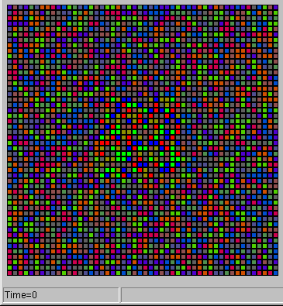
Sample 1 ABIR Landscape Without Territorial Border at t = 0 (above) and again at t =500 (below)

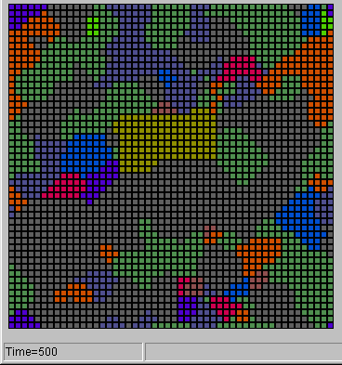

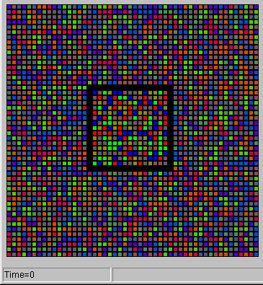
Sample 2 ABIR Landscape With Territorial Border at t = 0 (above) and again at t = 500 (below)

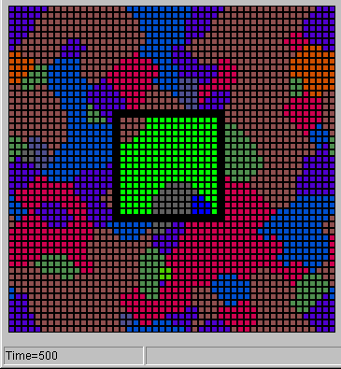

Figure 1. Two screenshots from separate ABIR histories at beginning (t = 0) and end of run (t = 500).

At the beginning of a "run" (which will be a “history” of the polity) the landscape can be "reseeded," randomizing both the distribution of activated identities and that of subscribed identities as well. In each period of history, or time-step, every agent observes the identities being activated by its eight neighboring agents (but not their unactivated identities—those we term subscribed) and the positive, negative, or neutral “bias” that the mass media is attributing to association with particular identities at that time. Each agent then responds to this information in one of three ways: (1) it maintains its currently activated identity into the next period; (2) it substitutes another identity from its repertoire as its newly activated identity; or (3) it replaces an identity within its repertoire with an identity previously absent from its repertoire. The simple algorithms which determine how and when an identity is included or extruded from an agent’s repertoire or activated by an agent were designed to correspond as closely as possible to the assumptions of constructivist theory and to well-established findings in social psychology that, ceteris paribus, individuals have multiple identities, that different identities are activated under different circumstances, that those identity sets can change over time, and that patterns of activation are related to generalized perceptions of the value of those identities and to patterns of identity activation immediately accessible to an individual.
In both this version and more advanced versions of ABIR many characteristics of the agents and the spaces they inhabit that are relevant to constructivist theory can be varied—characteristics such as local influence level, resistance to new identities, size of the neighborhood experienced as local, speed of reaction to shifts in the incentives attached to activation on different identities, size of repertoire, spatial concentration of types of agents, turbulence in the rate and extent of change in identity bias signals, and so on. In the experiments reported here, however, most of these characteristics are held constant.
Applying ABIR to Questions of Territory and Identity
In our exercise in virtual political geography we imagine a hypothetical and vastly simplified territorial space in which one distinctive region referred to as "National Homeland" is a 15 x 15 box (225 agents) and "World" is the remainder of the 50 x 50 global landscape (2275 agents). All residents of National Homeland are agents whose identity repertoires include exactly the same six identity options. Each of these six identities (ways, as it were, of "performing" their national identity) is activated by approximately equal numbers of agents randomly distributed across the National Homeland territory. The inhabitants of World, on the other hand, also have repertoires containing six identities (“alien” identities from the perspective of National Homeland). These alien identities are drawn at random from the remainder of landscape identities not counted among the six National Homeland identities. Since all landscapes used in these experiments feature fifteen identities present in the global identity spectrum, this means that the six identities in the repertoire of each agent in World were drawn from a set of nine different identities. Each of these nine identities is activated by approximately equal numbers of agents and randomly distributed across the territory designated World. It should be emphasized that we begin with the stark image that none of the World identities exist in National Homeland and that none of the National Homeland identities exist in World. From this basic template we then change distributions and locations of agents activated on different identities and containing different identity repertoires.
The abstract core of the theoretical issues of interest here can be framed as identifying the dynamics of the relationship between immigrants as carriers of naturalized identities on the one hand and native inhabitants of a territory who may be activated on different versions of a national identity but who all, at least initially, share the same set of identities in their repertoires on the other. In particular we have focused on the impact of (1) the varying prevalence of immigrant identities activated or in the subscriptions of inhabitants of a country; (2) territorial/political borders versus mere identitarian/cultural borders; and (3) the presence or absence of a “globalizing” supra-state identity. These three independent variables were operationalized in the following ways.
The Prevalence of Immigrants and Naturalized Identities
An immigrant is operationalized as an agent within National Homeland whose activated identity at the beginning of the run (t = 0 of the history to be produced) is an identity formerly present only in World. As carriers of a new identity into National Homeland, immigrants are assumed to have affected the identity repertoires of every other inhabitant of National Homeland. Although only those activated on a non-native identity at t = 0 are deemed immigrants, that activated non-native identity is also placed in the subscription of each native inhabitant of National Homeland. To achieve statistical simplicity and in support of our effort to focus on the abstract and fundamental dynamics of population composition and territory, the appearance of this immigrant or naturalized identity in each inhabitant's repertoire results in the removal of one specific previously available native identity from the repertoire of all non-immigrant agents. Note that the native agents who are reclassified as immigrants in this “reseeding” process are those for whom an activated native identity is replaced by an immigrant activated identity.
Let us consider an example that hopefully makes up in clarity what it may lack in realism. If the Dutch are deemed, as in our model, to have a total of six different "Dutch" identities in their collective repertoire, and in the individual repertoire of each inhabitant of the Netherlands, then after the arrival of one wave of immigration, one-sixth of the agents within the Netherlands, or all those activated on one particular way of being Dutch (e.g., Catholic), are now activated on a specific immigrant identity instead. This naturalized identity (e.g., North African Muslim) is an identity previously present in the world that was not present in the Netherlands prior to the arrival of the immigrants. As noted, we simplify the immigrant-native society relationship by imagining a simultaneous replacement of, for example, the Catholic way of being Dutch within the non-activated repertoires of all the other inhabitants of the Netherlands with the new non-native identity (Muslim).
To represent differing densities of immigrant populations or different degrees of cultural heterogeneity, three different versions of National Homeland have been constructed. In National Homeland One (NH1), one-sixth of the residents are immigrants. They are activated on one particular naturalized identity from World, replacing one native National Homeland identity. The unactivated identities in their repertoire include all five of the available native identities. The remaining five-sixths of the inhabitants of NH1 are natives activated in equal numbers on the five remaining native identities, but they now also have within their repertoires the naturalized identity activated by the immigrants. In National Homeland Two (NH2), two-sixths of the inhabitants are immigrants--one-sixth activated on each of two different World identities and all containing in their repertoires the four remaining native identities. That is to say, in NH2 two of the original native identities have been removed. The two-thirds of NH2 inhabitants comprising the native population are activated in equal numbers on the remaining four different native identities while containing within their repertoires each of the two non-native identities activated by the immigrants. Finally, in National Homeland Three (NH3), three-sixths of the residents are immigrants, activated in equal numbers on each of three naturalized World identities and containing within their repertoires all three available native identities. The other half of the inhabitants of NH3 are natives activated in equal parts on the remaining three native identities. Thus NH1, NH2, and NH3 differ incrementally from each other in the total number of immigrants and natives and in the number of different native and naturalized identities activated at t = 0, with NH1 containing the smallest percentage of immigrants (approximately 17%) and NH3 containing the largest percentage (50%).
Territorial/Political versus Identitarian/Cultural Borders
The second variable requiring operationalization is the distinction between physically enforced “territorial” borders on the one hand and “identitarian” borders on the other. We consider territorial borders as institutionalized demarcations of territory, usually associated with the officially sanctioned boundaries that separate one state from another. In contrast, identitarian or cultural borders, although they may correspond to territorial divisions, arise only from differences in the identities of clusters of inhabitants within a physically undivided space. For example, the territorial border of Albania is familiar and clear from map images of the Albanian state. But the Albanians outside that border who predominate in parts of Kosovo may present an identitarian or cultural border to non-Albanians that is different from physically enforced barriers to penetration by non-Albanians.
In the virtual worlds created by ABIR, the existence of a territorial boundary separating National Homeland from World is represented by a black border around National Homeland. This barrier prevents inhabitants on one side from perceiving or being influenced by agents near them but on the other side of the border. Thus it prevents pressures against the border from being directly transmitted across it. The border does not affect the reception of identity bias signals—mass media reports that register uniformly in World and in National Homeland, whether surrounded by a boundary or not.
If this territorial border is removed, National Homeland agents along the frontier are exposed to the identities activated by World agents adjacent to them, and they are therefore subject to potential cascades of pressure to similarly activate on a non-native identity. In other words, the only barrier that remains in the frontier area is an identitarian boundary between National Homeland and World, a barrier whose resistance to the smooth transmission of patterns of change on one side into patterns of change on the other is produced only by the degree to which the patterns of identity activation and the composition of identity repertoires of National Homeland and World inhabitants differ.
The Presence or Absence of a Globalizing Identity Wave
Our third operationalized variable is one particular pattern of change that can arise within a landscape—namely, powerful but locationally specific cascades of change toward a single activated identity. Under the right set of conditions, a critical mass of agents activated on the same identity can emerge and spread outward in a cascade of cultural “globalization.” These conditions include all of the following: (1) a sufficient concentration of agents in World in a sufficiently small area activated on the same identity, (2) a sufficient number of other agents in that area with that identity within their repertoires, and (3) a significant boost in the bias attributed to that identity sustained for enough time periods. For our purposes we stipulate that the presence of a “globalizing identity wave”--from the point of view of National Homeland—is indicated in the history under review if, at the end of its 500 time-steps, at least one of the non-native identities of the initial National Homeland immigrants (i.e., at t = 0) is also an identity which is activated by at least 40% of all agents on the landscape (i.e., those inhabiting World and National Homeland combined). Thus, although the settings for bias volatility and the range of variation of these biases remain the same across all histories and all experimental conditions, cascades of globalization arise only in a subset of them. Furthermore, recall that it is only a smaller subset of these cascades that we define as globalizing identity waves—namely, cascades of National Homeland immigrant identities.
It is important to distinguish here between what we consider to be two distinct but related forms of globalization. When territorial boundaries are present between National Homeland and World the only mechanism translating global events into changes in the complexion of National Homeland is the biases associated, globally, with different identities at different times. As noted, when territorial boundaries are present, all agents in National Homeland receive the same changing bias signals with the same volatility as do agents in World, but National Homeland inhabitants cannot be affected by cascades of a territorially-concentrated and expanding globalizing identity. We call this “parametric globalization,” referring to the kinds of global changes which are relatively unaffected by state boundaries (e.g., climate, information transmission, world commodity prices, etc.). When territorial borders are removed, the effects of a globalizing identity wave can be felt directly and in a territorially-specific fashion by inhabitants of National Homeland. Under these conditions, and when, in fact, a globalizing wave based on a World identity represented within National Homeland arises, we consider that “spatially-focused globalization” (e.g., trade, immigration, tourism, direct investment, international communication, etc.).

ABIR Experimental Findings
We can now focus our attention on the findings of several of our ABIR experiments. In these experiments, we examined two critical issues that help illuminate the interplay between spatially-focused and parametric globalization and their impact on matters of territoriality and identity. First, the question of the long-term viability of activated native identities within National Homeland was explored. Second, the phenomenon of “glocalization” and its tendency to disrupt the balance among alternative native identities was investigated. Outcome measures at time-step 500 were computed for each of 600 histories for each of the three different levels of immigration represented by National Homeland 1, National Homeland 2, and National Homeland 3 (i.e., a total of 1800 ABIR runs combined).

Type of Border

Territorial Identitarian
Globalizing  Identity Wave  Quadrant I
  Quadrant II
  Quadrant III
  Quadrant IV

Figure 2. Each ABIR history fits into one of the four quadrants of this 2 x 2 matrix, based upon the type of border surrounding National Homeland and the presence or absence of a globalizing identity wave.

Two of our three key independent variables can be represented as the two dimensions of a two-by-two matrix as depicted in Figure 2. The horizontal dimension designated across the top of the matrix distinguishes between whether, during any given history, National Homeland has a territorial border or instead only an identitarian border around its perimeter. The vertical dimension designated along the left side of the matrix distinguishes between whether a globalizing identity wave as defined earlier was present or absent during a given history. Within each of the four quadrants thereby created, we can use multiple sets of simulation runs with National Homelands to examine our third independent variable, namely, the proportion of immigrants present at time-step 0. Each ABIR history can be placed in one (and only one) of these quadrants. The most noteworthy features of each quadrant can be summarized as follows.
Quadrant I (Upper Left). This quadrant includes those histories characterized by a territorial border surrounding National Homeland and the absence of a globalizing identity wave. Of these experimental runs we may say that National Homeland experienced weak parametric globalization and no spatially-focused globalization. Here in Quadrant I, therefore, we would expect that the prospects for National Homeland to remain a region of distinctive identity and culture are most promising.
Quadrant II (Upper Right). In this second quadrant of the matrix are the histories produced when National Homeland had only an identitarian border and again, as in Quadrant I, a globalizing identity wave was absent. Of these histories we may say that National Homeland experienced weak parametric globalization and weak spatially-focused globalization. The designation of weak spatially-focused globalization reflects the fact that although National Homeland was not shielded by a territorial border from pressures emanating from World, these spatial pressures turned out not to meet our definition’s threshold as a globalizing identity wave. It might be said, then, that Quadrant II contains those histories in which National Homeland happened to escape the potentially considerable impact on its native identities that might have been produced had the activated identities of its immigrants proven more appealing in World.
Quadrant III (Lower Left). In this quadrant are the histories produced when National Homeland had a territorial boundary and a globalizing identity wave was present. Therefore, although National Homeland experienced no spatially-focused globalization (by virtue of the territorial boundary), it was subject to strong parametric globalization. Under this combination of conditions native inhabitants of National Homeland were fully protected from direct contact with outside influence. It may be expected, however, that National Homeland’s native identities were still at risk because an immigrant activated identity was favorably advantaged in the landscape as a whole (by the high biases which tend to be associated with a globalizing identity wave).
Quadrant IV (Lower Right). In this final quadrant are the experimental histories produced when National Homeland was surrounded by only an identitarian border and a globalizing identity wave developed. As a result, we may say that National Homeland experienced strong spatially-focused and strong parametric globalization. This then is the quadrant of greatest apparent jeopardy for the preservation of native identities as the preferred ways of being within National Homeland. Not only is there no territorial border preventing World residents from impacting the identity choices of National Homeland inhabitants, but at least some of the immigrants within National Homeland have adopted an activated identity that has proven broadly popular beyond its borders. Snowball effects or cascades in favor of this identity can flow directly against National Homeland residents reinforcing efforts by those activated on that advantaged identity to activate their neighbors.

The Long-Term Viability of Native Identities
The long-term viability of native National Homeland identities was assessed using two related outcome measures. The first measure was a percentage comparison of the absolute number of agents within National Homeland activated on any native identities at time-step 500 versus time-step 0. Figure 3 presents the average values for this variable in each quadrant for each of the three National Homelands (NH1, NH2, and NH3). Note that the number of ABIR histories varies for each condition (this is true for all subsequent results as well). These disparities in sample size reflect naturalistic differences in the occurrences of the circumstances that define each quadrant.
The findings reported in Figure 3 for NH1, NH2, and NH3 are more readily interpretable against a “baseline” standard for a National Homeland in which there are no immigrants whatsoever at time-step 0. For this purpose, a separate set of ABIR histories (600 runs) was collected for a “National Homeland Zero” (NH0) in which all inhabitants were natives with repertoires that shared no identities in common with the residents of World. Half of these runs included a territorial border around National Homeland (i.e., no spatially-focused globalization), and in all of these cases the number of agents activated on native identities necessarily remained constant at 100% over time because there was no possibility of an activated non-native identity appearing within the NH0 borders. For the other half of the runs, NH0 and World were separated by an identitarian border only. In these cases, the average outcome measure value at t = 500 was 101.6%. This percentage indicates that when there were no immigrants within NH0 at t = 0 (and therefore by definition no possible globalizing identity wave), a territorial border was not needed to prevent switching from native to non-native activated identities.
If we now turn to Figure 3, a general but imperfect pattern is observable when comparing the three different National Homelands NH1, NH2, and NH3. The percentage values for NH3--with the greatest number of immigrants initially--were consistently lower than the corresponding values for NH1. Thus, the larger initial presence of immigrants in NH3 appeared to apply more pressure on the native population of National Homeland to convert to an activated non-native identity. But beyond this finding, there are also noteworthy differences in the magnitude of this effect depending upon which of the four quadrants of our matrix we consider.
For example, on average the impact of immigrants on native identity representation over time was nonexistent when National Homeland was insulated by a territorial border and none of the immigrant identities within National Homeland established a globalizing identity wave (i.e., Quadrant I). Indeed, under these conditions of no spatially-focused globalization and only weak parametric globalization there was a slight tendency for the proportion of National Homeland residents activated on native identities to actually increase, rather than decrease, over time. In other words, rather than fighting a losing battle to maintain their representation within National Homeland, inhabitants expressing native identities not only held their own but actually succeeded in convincing immigrants to activate on native identities as well. In Quadrant II the pairing of weak spatially-focused and weak parametric globalization produced a decline over time in the percentage of National Homeland residents activated on a native identity--more so when immigrants were more highly represented at t = 0 as in NH3--but these losses were still relatively modest when compared with the effects witnessed in the matrix’s lower quadrants.

Type of Border

Territorial Identitarian

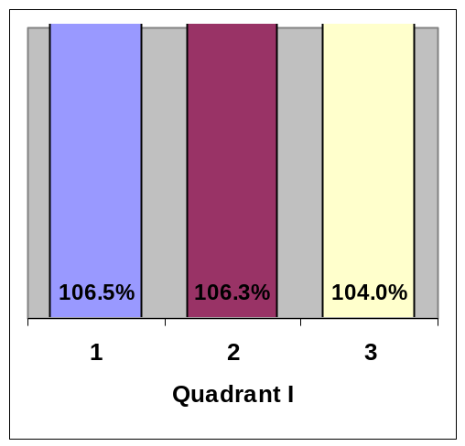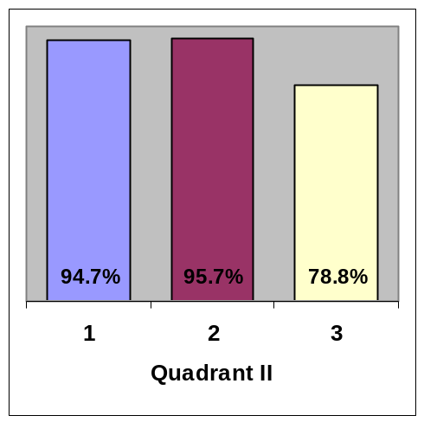

Globalizing
Identity Wave
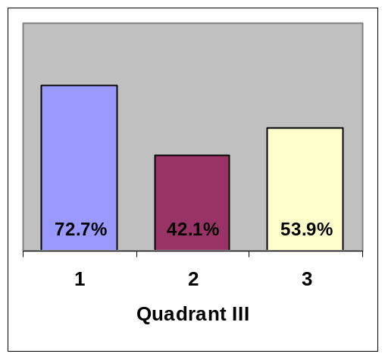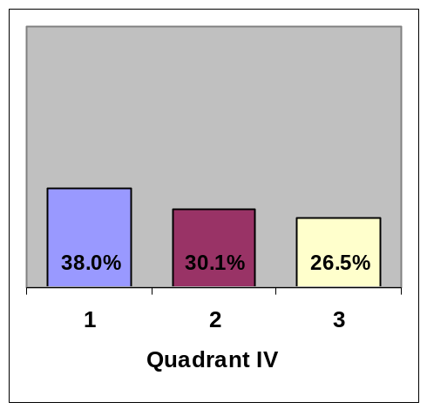

Figure 3. Average Percentage of National Homeland Residents Activated on a Native Identity at t = 500 Compared to t = 0. N’s for NH1, NH2, and NH3 in each quadrant are as follows: Q1 (277, 255, 213), Q2 (268, 243, 216), Q3 (23, 45, 87), and Q4 (32, 57, 84).

Quadrants III and IV share in common the presence of a globalizing identity wave—that is, the histories included in both quadrants featured conditions of strong parametric globalization. They differ from each other in regard to whether it was a territorial border (Quadrant III) or only an identitarian border (Quadrant IV) that served to protect National Homeland’s perimeter from the influence of neighboring World residents. As the average percentages in Quadrant III indicate, when confronted with a globalizing identity wave even National Homeland’s impermeable territorial border was clearly insufficient to prevent widespread conversion to activated immigrant identities by National Homeland natives. The magnitude of this conversion was even more pronounced in Quadrant IV where exposure to strong spatially-focused globalization as well as strong parametric globalization produced dramatic declines in National Homeland residents activated on native identities at t = 500. Still, the protective role that territorial boundaries do play is clearly reflected in the fact that the average prevalence of native identities at t = 500, across all homeland conditions, is 78.3% higher in Quadrant III than in Quadrant IV.
The second outcome measure used to assess the long-term viability of native National Homeland identities was a simple count of the number of ABIR histories in which at t = 500 there were no longer any National Homeland inhabitants activated on any native identities. In other words, we asked the question “How often does National Homeland become the exclusive province of residents activated on non-native identities?” This eventuality occurs only when all of the native inhabitants of National Homeland are persuaded to switch to one of the identities brought into National Homeland by the immigrants from World. Note that there were no cases of extinction in “baseline” runs where there were no immigrants in National Homeland at t = 0. Figure 4 presents results in the form of the percentage of histories—“extinction histories” --in which total activated native identity extinction occurs. Again, the quadrants of our matrix reveal noteworthy differences.

Type of Border

Territorial Identitarian

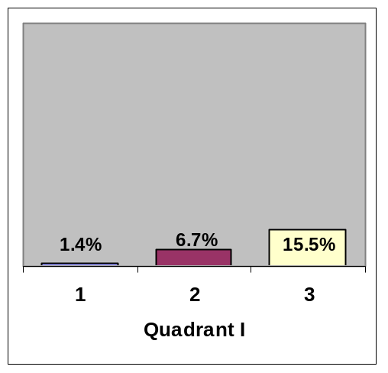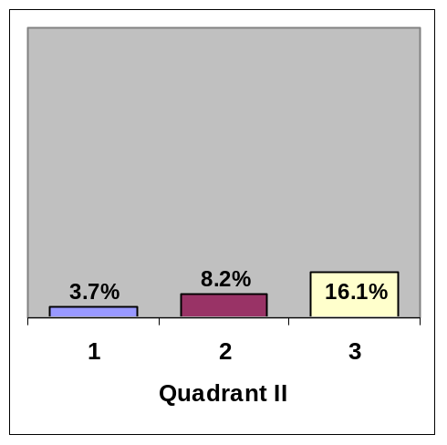

Globalizing
Identity Wave
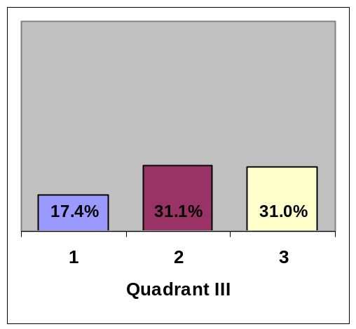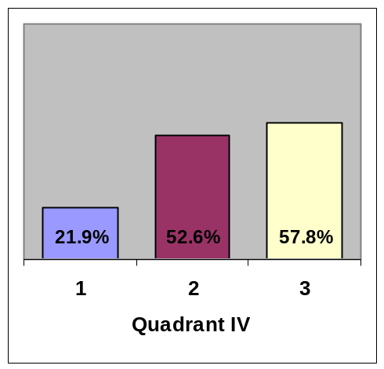

Figure 4. Percentage of Runs In Which No National Homeland Residents Are

Activated On a Native Identity at t=500. Ns for NH1, NH2, and NH3 in each

quadrant are as follows: Q1 (277, 255, 213), Q2 (268, 243, 216), Q3 (23, 45, 87),

and Q4 (32, 57, 84).

In Quadrant I, National Homeland’s native population was doubly protected by an impenetrable territorial border and the failure of a globalizing identity wave to emerge (i.e., no spatially-focused globalization and only weak parametric globalization). Under these conditions extinction histories represented a very low percentage of the overall runs. They ranged from a low of 1.4% for NH1 up to a modest 15.5% for NH3. Comparable levels of extinction were found in Quadrant II as well (weak spatially-focused globalization coupled with weak parametric globalization), indicating that by this measure the presence or absence of a territorial (compared to mere identitarian) border was inconsequential as long as National Homeland was not subjected to an alien globalizing identity wave.
If we now move to the lower half of the matrix we see substantially higher rates of activated native identity extinction. In Quadrant III, despite the presence of a territorial border surrounding National Homeland (i.e., no spatially-focused globalization), the percentage of histories in which all residents relinquished their native activated identities in favor of non-native activated identities was elevated substantially above the corresponding figures for Quadrant I for all three National Homelands. Thus, we can see that the presence of a globalizing identity wave (i.e., strong parametric globalization) had a significant impact.
The results were even more striking for Quadrant IV, where National Homeland’s boundary was only identitarian in nature and a globalizing identity wave occurred. The extinction rates were sharply higher for Quadrant IV than Quadrant III, indicating that a territorial border eliminating the influence of spatially-focused globalization played a meaningful protective role when strong parametric globalization pressures were present. Indeed, in NH3 where natives and immigrants resided in equal numbers at t = 0, for well over half of the histories in Quadrant IV there were no longer any inhabitants activated on a native identity at t = 500. Also, the greater disparities between Quadrants IV and II than between Quadrants III and I reveal that the presence or absence of a globalizing identity wave made much more of a difference when the barrier between National Homeland and World was solely identitarian rather than territorial.

The Parochialization of Native Identities
Thus far we have focused on ABIR findings pertaining to the protection of native expressions of distinctive national identities in a country moving toward greater commonality and association with other polities. We now shift our attention to “reactive nationalism” or, more generally, “glocalization,” a phenomenon equally of interest to this discussion because it raises questions about the preservation of diversity within an individual country in regard to the breadth of variety in the manner in which native national identity is expressed. The term itself refers to a syndrome of parochial mobilization arising within states exposed to severe globalizing pressures. These manifestations of what Barber has iconized as “Jihad” in reaction to “McWorld” press the nation-state from within and below even as it is being squeezed from above and without by global economic and cultural forces. We make no claims here as to the potency of this kind of threat to the integrity of the nation-state. But by defining glocalization in terms of a parochialization of identity—a reduction in the manifest diversity of native ways of performing the national—we can examine the extent to which glocalization can arise as a typical result of certain kinds of encounters in a constructivist world rather than as a pathology associated with particular cultures or civilizational “levels.”
Our ABIR experiments measured parochialization effects in two different but related ways. The first measure evaluated native identity concentration in National Homeland at time-step 500 for each run by using the Herfindahl Index, which is traditionally employed to describe the extent of concentration in an industry or market for econometric or anti-trust purposes. In our case, this index was the sum of the squares of the proportional representation of each native identity (relative to the total number of National Homeland agents activated on native identities). Since ABIR histories in which all native identities were extinguished could not be used to assess the concentration of remaining native identities, these runs were excluded from the index calculations.
Figure 5 presents these average Herfindahl Index values for each quadrant. The highest possible score reflecting maximum concentration is 1.00, indicating that all remaining agents activated on a native identity were in fact activated on the same identity. The minimum concentration scores varied from one National Homeland to another, based on the number of available native identities at t = 0. These minimum possible Herfindahl Index values were .20, .25, and .33 for NH1, NH2, and NH3 respectively. It should also be noted, for comparison purposes, that the index score at t = 500 for 600 “baseline” histories in which no immigrant identities were placed in National Homeland (i.e., NH0) was .61 (with a minimum possible value of .17). This value in itself indicates that substantial consolidation among native identities occurred even without outside influence.

Type of Border

Territorial Identitarian

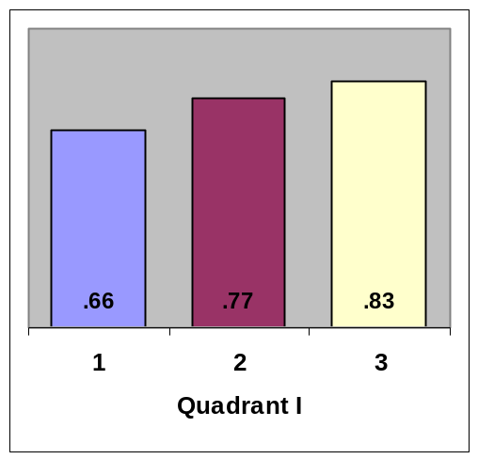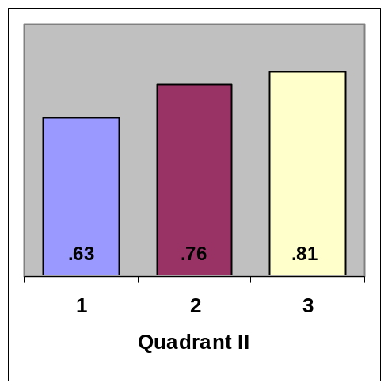

Globalizing
Identity Wave
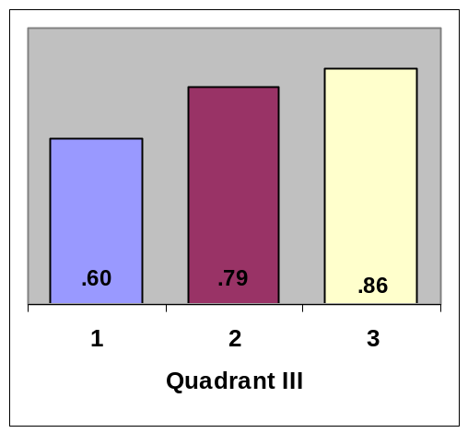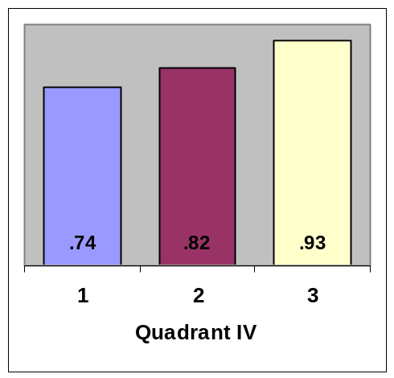

Figure 5. Average Herfindahl Index As Measure of Concentration of Native Identities Among National Homeland Residents at t = 500 for Histories in Which Complete Extinction Did Not Occur. N’s for NH1, NH2, and NH3 in each quadrant are as follows: Q1 (273, 238, 180), Q2 (258, 223, 181), Q3 (19, 31, 60), and Q4 (25, 26, 36).

The findings here reveal an important general trend with all four quadrants displaying the same pattern: at t = 500 there was, on average, increasing levels of concentration among remaining activated native identities as we move from NH1 to NH2 to NH3. The average Herfindahl Index scores across all quadrants were .66 for NH1, .79 for NH2, and .86 for NH3. That is, the presence of more immigrants at t = 0 (and therefore fewer native residents and fewer native identities in the repertoire) tended to produce greater concentration of activated native identities over time regardless of border type or presence versus absence of a globalizing identity wave. However, beyond this overall pattern, we see a noteworthy accentuation in this consolidation process in Quadrant IV. Here, where the native National Homeland agents were exposed to strong spatially-focused globalization (the border between National Homeland and World is strictly identitarian) and a globalizing identity wave (i.e., strong parametric globalization), the average Herfindahl Index scores reached higher levels than in the other three quadrants. Indeed the .93 value for NH3 in Quadrant IV is quite close to the maximum possible value of 1.00.
A related second outcome measure of parochialization sheds further light on the constriction in the range of alternative activated native National Homeland identities over time. The variable we employed for each history was the number of different native National Homeland identities still activated (by at least one agent) at t = 500. Individual runs in which there were no activated native identities left at t = 500 were excluded from the analysis, again because such histories could not be used to measure changes in native identity concentration over time. This means that the minimum possible value for the outcome measure was 1—rather than zero—since at least one agent activated on a native identity was required for inclusion.

Type of Border

Territorial Identitarian

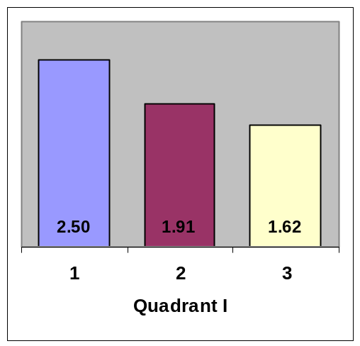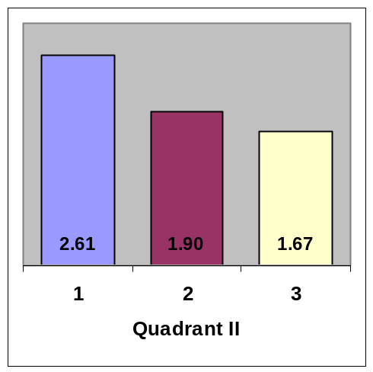

Globalizing
Identity Wave
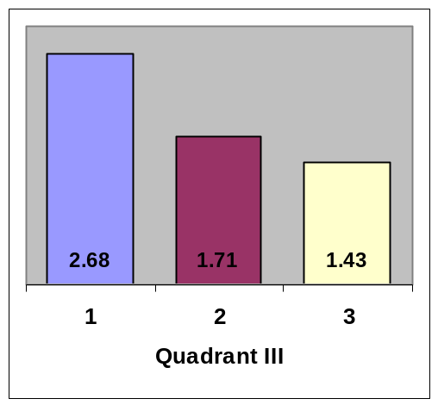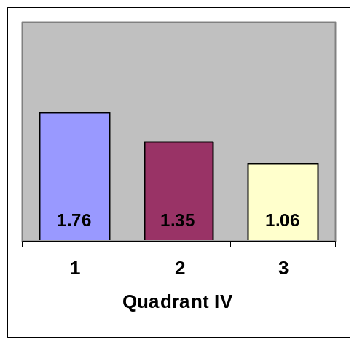

Figure 6. Average Number of Different Activated Native Identities Among National Homeland Residents at t=500 for Histories in Which Complete Extinction Did Not Occur. Ns for NH1, NH2, and NH3 in each quadrant are as follows: Q1 (273, 238, 180), Q2 (258, 223, 181), Q3 (19, 31, 60), and Q4 (25, 26, 36).

Note that for NH1 there were initially 5 different activated native identities, for NH2 there were initially 4 different activated native identities, and for NH3 there were initially 3 different activated native identities. Figure 6 presents the average number of activated native identities remaining at t = 500 for each quadrant of the matrix. In considering these values, it is again important to compare them with baseline figures established from histories in which National Homeland had no immigrants whatsoever at t = 0 (i.e., for NH0 in which there were initially 6 different activated native identities). For these 600 runs the average number of different native identities remaining at t = 500 was 2.92.
If we now turn our attention to Figure 6, there is a general trend across quadrants for this variable similar to that observed for the Herfindahl Index scores in Figure 5. All of the average values were well below the corresponding original complement of native identities for each National Homeland, indicating a glocalization-relevant effect of substantial declines in activated native identity diversity over time. In addition, within each quadrant the average number of different activated native identities at t = 500 was proportionally smaller when more immigrant agents, and fewer native agents, were included in National Homeland at t = 0.
Not surprisingly, the most dramatic decline in the diversity of activated native identities occurred in Quadrant IV where the combination of strong parametric globalization and strong spatially-focused globalization took a severe toll. For example, the 1.06 value for NH3 is barely above the minimum possible value of 1.00 (which equates with a complete loss of diversity). This value also represents an average loss of 1.94 (activated native identities) over time, which is very close to the maximum possible loss of 2.00 (i.e., from the original 3 activated native identities in NH3 to only 1 identity). On a percentage basis, this average decline is fully 97% of the largest decline possible. Also noteworthy is the greater disparity between Quadrants IV and II than between Quadrants III and I. This distinction again indicates that the presence of a territorial border around National Homeland served to limit, to some degree, the impact of a globalizing identity wave.

Conclusion: Territorial Borders, Globalization, and the Parochialization of Native Identities
Formal models, whether statistical, game-theoretic, or, as in our work, agent-based or computational, are intended to identify the importance of variables otherwise obscured or under-appreciated. The ruthlessness of their abstractions means that deploying these models drains enormous amounts of detail from the situations being modeled. Thus the successful use of formal models cannot be measured by the production of a recognizable and satisfying snapshot of the composite set of circumstances and forces under investigation. Instead, the usefulness of any of these approaches is that by teaching us something about unabstracted realities, they can show the potency of the variables they do focus on even if most of the actual content is removed. This is, of course, as it should be. In physics, abstract models filled with frictionless planes, constant velocities, and perfect spheres illuminate the fundamental importance of key relationships between mass, motion, and acceleration. Such models teach us about automobile crashes, even though all of what we know, or can know, about speed, location, malfunction, gasoline, rust, human error, irregularity of materials, and road conditions is removed from the target of analysis.
In the experiments reported here we have indeed ruthlessly drained cultural distinctiveness, history, and many other elements of interest from the problem of studying territorial borders and their relationship to the effects of mixing new identities into a national polity. On the other hand, we have strived to organize our research so as not to contradict what is generally accepted--and believed by us--to represent the fundamentally constructivist dynamics of identity formation and change. While we have used Europe as a source of folk examples and as a loose narrative for explaining the strategic intent of our experiments, we have made no claims to be modeling anything specific about territory, identities, or processes of migration and cultural transmission in contemporary Europe.
Yet we believe we have learned some things that may help us and others better understand the forces operating in Europe. One conclusion we can draw is that, indeed, territory does matter, but it matters under some circumstances more than others. When globalizing forces are relatively weak or non-existent--when the outcome of processes of identity change are determined more or less completely by the resolution of forces operating within the state--a territorial border that physically demarcates the separation of the state from the rest of the world is largely unnecessary for the protection of the survival and predominance of native identities within the polity. This is especially the case when the proportion of inhabitants embracing naturalized, formerly alien identities, is relatively small.
Thus, noting the NH3 bar in Quadrant II of Figure 3, we see that even in a polity where at t = 0 half of the residents are activated on immigrant rather than native identities, an average of 78.8% of inhabitants initially expressing themselves in native idioms are still doing so at the end of the history under observation. In NH1 and NH2, where the proportions of immigrant identities are lower, the corresponding averages at t = 500 are well over 90%. In other words, under these conditions identitarian borders--distinctions between the polity and the world arising out of the complexion of identity commitments rather than out of physical or territorial borders per se--can provide reassurance to inhabitants embracing native variants of the national identity that they will not be submerged or made irrelevant by the presence of naturalized, previously alien identities.
However, under conditions of strong parametric and spatially-focused globalization (Quadrant IV) and substantial cultural heterogeneity (NH3), territorial boundaries play a crucial role in preventing the presence of naturalized identities, and inhabitants expressing those identities, from swamping the state and reducing or even displacing native ways of performing the national. Again with reference to Figure 3 we note that native identity survival rates are significantly reduced by the presence of a globalizing identity wave (Quadrants III and IV compared to Quadrants I and II), but, just as dramatically, that the presence of a territorial border (Quadrant III) affords substantially more protection against the impact of globalizing cascades of identity transformation than does the presence of an identitarian border only (Quadrant IV).
The same conclusion emerges from consideration of the data displayed in Figure 4. Here we compare rates of extinction of all activated native identities in each of the three National Homelands under each of the four conditions of exposure to parametric and spatially-focused globalizing forces. Again we find that when globalizing forces are relatively weak (Quadrants I and II), at least some inhabitants of each National Homeland remain activated on a native identity at t=500 in a very high percentage of the histories. Unsurprisingly we also observe that as the initial presence of non-native identities increases (moving from NH1 to NH2 to NH3) the number of extinction histories also rises (but still remains small). We can see as well that, under these conditions of weak globalization pressures, there is little difference between territorial versus identitarian borders. However, comparing Quadrants III and IV to Quadrants I and II reveals that potent globalizing forces do substantially increase the extinction rates of activated native identities. Indeed the lowest extinction rate when a globalizing identity wave was present (17.4% for the native identity-rich and territorially-bounded NH1 in Quadrant III) was greater than the highest extinction rate when such a cascade was absent (16.1% for the immigrant-rich and identitarian-bordered NH3 in Quadrant II).
By comparing Quadrant III, where a territorial border is present, to Quadrant IV where only an identitarian border is present, we can also see the effect of strong spatially-focused globalization in concert with powerful parametric globalization. The rates of extinction for activated native identities are markedly higher in Quadrant IV than in Quadrant III where territorial borders block the impact of spatially specific cascades of identity change emanating from beyond National Homeland. This impact of strong globalizing forces on the likelihood of activated native identity extinction is especially striking when the proportion of immigrants in National Homeland rises from one-sixth of the population (NH1) to one-third and one-half (NH2 and NH3). An apparent threshold effect is manifested in the particularly sharp increase in extinction histories under conditions where spatially-focused globalization is added to parametric globalization. In Quadrant IV we see the incidence of native identity extinction rising from 21.9% in NH1 to over 50% in both NH2 and NH3.
The other significant finding to emerge from our experiments pertains to “glocalization,” or reactive nationalism, a phenomenon that figures in many efforts to understand the impact of migration on different European countries. Switzerland is the European country with the highest proportion of foreign-born inhabitants—20%. Although in some parts of Switzerland the proportion of foreign-born reaches 30% and although these inhabitants do not (yet) enjoy Swiss citizenship, we can see that our three different National Homelands, featuring proportions of one-sixth, one-third, and one-half naturalized inhabitants hailing from outside National Homeland borders, are on the high end of what most European countries have yet experienced. On the other hand, if we take into account waves of immigrants who have become naturalized citizens of different European countries, or whose children and grandchildren are raised as nationals of their countries of habitation, then one can appreciate that the proportions used in our experiments are not terribly discrepant with European realities. Considering the invigoration of anti-immigrant movements in Britain, France, Germany, Denmark, and elsewhere, and the concomitant rise of xenophobic, nativist nationalisms, the questions our experiments pose in the abstract are of direct relevance to the interactive meaning of territory, population, and boundaries in contemporary Europe.
Since our model is thoroughly abstracted from any particular country, we may say that our findings in regard to nativist parochialization in response to globalization and immigration is independent of any specific cultural or psychological disposition seen as peculiar to particular European countries. We also note that patterns of parochialization that we find indicate a narrowing of native mobilization, but not the direction that narrowing will take (reaction against globalization or bandwagoning moblization in imitation of it). Thus our work cannot be read as a guide to understanding political culture change in any particular European country or as a prediction of which strains in the native identity repertoire will prosper at the expense of others. However our study of the dynamics of processes leading to nativist parochialization can suggest (1) whether such developments are to be expected in any polity whose borders open wide to global market forces and the movements of people and ideas from within and from outside Europe; and (2) whether there are trigger or tipping points beyond which dramatic and frightening challenges to native inhabitants are especially likely.
We did find a glocalization effect, but it was not as generalized as the effects we found globalization and cultural mixing to have on the prevalence of native identities. Instead we observed a tendency, under all experimental conditions including those with weak and with strong spatially-focused and parametric globalization, for increasing levels of cultural mixing (moving from NH1 to NH2 to NH3) to produce moderately more parochialization among activated native identities as measured by the Herfindahl Index. For example, the National Homeland index averages (see Figure 5) are remarkably similar for Quadrants I, II, and III--where spatially-focused globalization forces were either weak or absent—and in most conditions well above the baseline Herfindahl Index value of .61 (for those NH0 histories in which National Homeland had no immigrants at all). However, in Quadrant IV, where strong spatially-focused globalization and strong parametric globalization pressures were both present, we found evidence (Herfindahl Index averages ranging from .74 for NH1 all the way up to .93 for NH3) of the kind of intensive parochialization associated with the glocalization or reactive nationalism phenomenon. In sum, then, we observed a tendency toward convergence toward a subset of national identities (even in the absence of strong globalization pressures), a significant increase in the tendency toward that convergence when cultural mixing is introduced, and an even greater increase in this parochialization tendency when the absence of territorial barriers directly exposes residents of the polity to the effects of globalizing identity waves.
The data displayed in Figure 6 provide another cut at the same phenomenon. Here patterns of parochialization of activated native identities appearing in our histories are examined by measuring the average number of different native identities still being expressed by inhabitants at the end of the measured history, in each National Homeland and under each set of globalizing pressures. The lower the number of different activated native identities, the higher the degree of parochialization. Again we find under all experimental conditions, regardless of level of spatially-focused or parametric globalization, that increasing levels of cultural mixing (moving from NH1 to NH2 to NH3) tend to produce more parochialization among activated native identities. As measured in this fashion, it appears that the most marked change in parochialization occurs in the transition between NH1 and NH2 (i.e., between circumstances of low to medium presence of immigrants). Finally, as we noticed when using the Herfindahl Index, we again see here a significant increase in parochialization when the polity, however mixed culturally, is deprived of a territorial boundary to protect it from the direct effects of strong spatially-focused globalization (i.e., Quadrant IV).
That we have documented certain effects and relationships in the virtual worlds we have created with ABIR does not prove that these patterns exist in the real world. Nor does our work show that if they do exist, that they are produced by the algorithmic processes and mechanisms of emergence identified in our analysis of the virtual world. The real world, after all, is filled with specificities, qualifications, and gradients absent in our analysis. Many of these details suggest avenues for further research with ABIR, now that we have shown ourselves able to produce virtual polities whose behavior--in terms of identity change, responses to different kinds of globalization, and to different proportions of cultural mixing--seem to correspond to some real world patterns.
For example, boundaries in the real world are neither entirely sealed nor entirely open, and in other experiments we are examining the effects of gradually increasing the porosity of territorial borders in relation to globalizing pressures. In the real world the arrival of immigrants or identities does not appear as a perfect substitution of one new identity for one previously present identity at both the level of activation and subscription. In the real world inhabitants of states have different sizes of repertoires and are differentiated in other ways—influence over one another, alertness to change in the environment, flexibility in response to opportunities for change, and so on. Each of these variables can be captured in the virtual world using ABIR, but we have followed the “KISS” strategy advocated by a leading developer of agent-based modeling techniques in the social sciences, Robert Axelrod: “Keep it simple stupid.” In this way we can systematically evaluate contributions to our understanding of the phenomena of interest as more complexity is added to the model.
It is this strategy which allows us to say some significant things, even though our virtual operationalizations are so brutally simplified. We can fairly conclude, for example, that the fundamental assumptions of constructivist identity theory are perfectly compatible with patterns of identity change and mobilization associated with globalization and glocalization in Europe; that globalizing forces acting in a localized fashion across borders must be distinguished from those whose effects are less spatial and more parametric; that emotional, socio-economic, or historical variables, although they may add to our understanding of the patterns we have traced, are not necessary for explaining why they arise; and that territory and territorial boundaries matter, especially when significant cultural mixing has already occurred and when globalizing pressures are intense.

Concerning the trend in immigration research toward the application of constructivist theories of nationalism, ethnicity, and identity see Nancy Foner, RubéG. Rumbaut and Steven J. Gold, “Immigration and Immigration Research in the United States,” Items and Issues, Vol. 2, no. 1-2 (Summer 2001) pp. 1-6.
From the perspective of t=0 (before the beginning of a simulation) the run can be considered a “future.” From the perspective of the end of the simulation, it can be considered a “history.”
For full color images of the figures in this chapter see: http://www.polisci.upenn.edu/abir/_private/publications/EideLust.doc
This “bias” appears in the model as a negative or positive integer or as zero. When added to the assessment of the different identities appearing in an agent’s neighborhood, the bias value affects the behavior of the agent as regards maintaining the agent’s activated identity, changing it, or substituting a new identity for a currently subscribed one. Bias values change randomly within a specified range to represent variation in the attractiveness of various identities. In the experiments reported the bias assigned to a particular identity in a particular time step could change with a probability of .0009 to take on integer values between –2 and +2 inclusive.
For a complete specification of these algorithms, or "micro-rules" see Ian S. Lustick and Dan Miodownik, “Deliberative Democracy and Public Discourse: The Agent-Based Argument Repertoire Model,” Complexity (2000) Vol. 5, no. 4, pp. 29-30. For useful illustrative treatments of social identity theory as a prominent approach to identity issues in social psychology based on constructivist assumptions see Dominic Abrams and Michael A. Hogg, “An introduction to the social identity approach,” and Michael A. Hogg and Craig McGarty, “Self-categorization and social identity,” in Social Identity Theory: Constructive and Critical Advances, Dominic Abrams and Michael A. Hogg, eds. (New York: Springer-Verlag 1990) pp. 1-9 and 10-27. See also Gi-Wook Shin, James Freda and Gihong Yi, “The politics of ethnic nationalism in divided Korea,” Nations and Nationalism, Vol. 5, no. 4 (1999) pp. 465-484.
For published work reporting results of research conducted so far see Ian S. Lustick, “Agent-Based Modelling of Collective Identity: Testing Constructivist Theory,” Journal of Artificial Societies and Social Simulation (January 2000) Vol. 3, no. 1 http://jasss.soc.surrey.ac.uk/3/1; and Ian S. Lustick and Dan Miodownik, op. cit., pp. 13-30; and Ian S. Lustick and Dan Miodownik, “The Institutionalization of Identity: Micro Adaptation, Macro Effects, and Collective Consequences,” Studies in Comparative International Development (forthcoming 2002). To download an executable version of the ABIR program, along with a manual explaining its use, see http://www.psych.upenn.edu/sacsec/abir/_private/Simulation%20Software.htm
In the histories displayed in Figure 1, the National Homelands contain four different activated native identities (particular shades of red, green, blue, and khaki) and two different activated immigrant or naturalized identities (particular shades of gray and brown).
Return to Figure 1 to note the operationalization of the territorial boundary in the history displayed on the right side of the figure.
For more detailed discussions of glocalization effects see Barry Axford, The Global System: Economics, Politics and Culture (Cambridge, MA: Polity Press, 1995); Benjamin Barber, Jihad Versus McWorld (Times Books, 1995); and Uri Ram, “Postnational Pasts,” Social Science History 22:4, pp. 513-545.
Robert Axelrod, The Complexity of Cooperation: Agent-Based Models of Competition and Collaboration (Princeton: Princeton University Press, 1997) p. 5.

